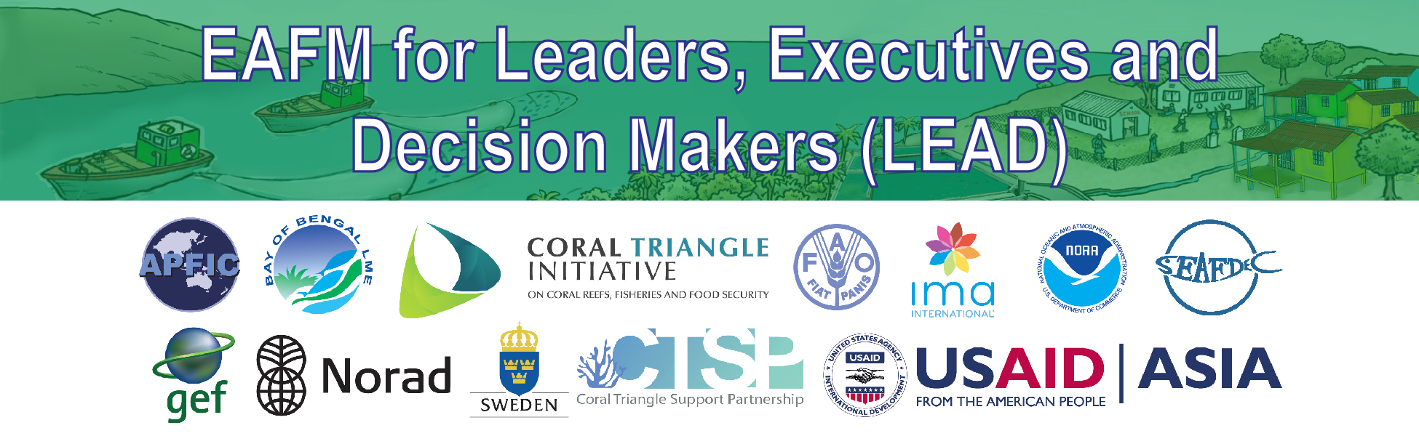

A1: Conversation

One and two minute scripts for engaging with LEADers

PURPOSE
This tool is intended to provide guidance on how to engage an executive officer (typically senior Department of Fisheries, Fishery or Agriculture Minister or Secretary, or Provincial governor or equivalent) to promote the concept of EAFM as a tool to address a challenge in a fishery. It is expected that there is a narrow window of opportunity to engage an executive officer and to present a short outline of the challenge to be addressed and the proposed solution.

HOW TO USE THE DOCUMENT
This document should be used together with:
- “Hot news” and the LEAD course [A2: Conversations]
- Common issues in fisheries [B1: Reference material]
- How many EAFM-type actions are you already doing and how are they linked? [B3: Reference material]

KNOW THE TARGET
- Know the target for your communication
  - Google and/or talk with in-country representatives to learn more about the leader/minister to be approached
  - Identify topics of importance for them.
  - Know the current policies or initiatives and try to link these to how EAFM can deliver the outcome

DEVELOP A SHORT CHECKLIST OF TALKING POINTS
- Review the issues
  - What is likely to be of political interest to the intended target
  - What are the “hot topics” for the country/province
  - Be country/locality specific
- Explain what EAFM is good for
  - Link the status of the fisheries, habitats, human components and how fisheries are currently being managed
  - Apply 3 components of EAFM to discussion: human well-being; ecological well-being; good governance
  - Explain “why” EAFM is significant to the country (tying to hot topics and/or topics of interest) and how traditional fisheries management is failing
- Discuss how steps can be taken to initiate an EAFM approach or an EAFM plan

ENGAGE WITH THE EXECUTIVE
- Engaging the target
- Transitional statement (optional)
- Setting the stage
- What is the EAFM
- Why use the EAFM
- Wrap up

Example: “ 1 min script” to include above information (should adapt depending on situation):

Engaging the Target:

YOU: Hello, Mr./Ms. Very Important Person. I understand that you have been recently briefed on a recent, violent conflict in Chumphon province between trawls and trap fishers.

VIP: Indeed/I know

Transition Statement:

YOU: I have been also working on this and believe that we have a way to address this issue in a manner that supports the mission of our ministry.

VIP: Really?

Setting the Stage:

YOU: Some people in the Ministry, including myself, have been trained to implement a process used to address ecosystem challenges.
It is called the Ecosystem Approach to Fisheries Management (EAFM).

VIP: What is EAFM?

What is EAFM

YOU: EAFM promotes sustainability by balancing the well-being of people with the health of the environment through good governance.
This is done by including extensive stakeholder participation.

VIP: But don’t we do these things already?

Why use EAFM

YOU: Yes, but we are not doing them in a holistic integrated approach. The EAFM process can reduce conflict through a defined, holistic process that will help the stakeholders come to a solution.
A solution will also lead to better compliance of our laws.

Wrap Up

I would be happy to talk with you further or provide additional information. Thank you for your time.

Example: “ 2 min script” to include above information (should adapt depending on situation):

Engaging the Target:
YOU: Hello, Mr./Ms. Very Important Person. I understand that you have been recently briefed on a recent, violent conflict in Chumphon province between trawls and trap fishers. This is an important issue for us to resolve in order to encourage the resumption of sustainable fishing and respect for the fisheries management plans.

VIP: Indeed/I know

Transition Statement:
YOU: I have also been working on/thinking about this and believe that we have a way to address this issue in a manner that supports the mission of our agency/ministry.

VIP: Really?

Setting the Stage:
YOU: Some people in the Ministry, including myself, have been trained to implement a process used to address ecosystem challenges. It is called the Ecosystem Approach to Fisheries Management (EAFM).

VIP: What is EAFM?

What is EAFM
YOU: EAFM promotes the sustainable development and a way to sustainably maximize the ecosystem benefits. It does this by balancing the well-being of people and the health of the environment through good governance. It is a process that involves 5 steps: Plan, Do and Check & Improve. This is done by including extensive stakeholder participation.

VIP: But don’t we do these things already?

Why use EAFM
YOU: Yes, we are doing aspects of EAFM but not in a holistic approach. The EAFM process can reduce this trawl/trap conflict in Chumphon Province through a defined, holistic process that will help the stakeholders come to a solution. A solution will also lead to better compliance of our laws. EAFM has been introduced in the region and is an appropriate tool that supports participatory fisheries management.

Wrap Up
I would be happy to talk with you further or provide additional information. Thank you for your time.

